Gbm.auto hyperparameter optimisation paper
Hyperparameter optimisation in Boosted Regression Tree models

Introduction
Treated as black box but improvements have happened, more info is available on performance metrics, interim results, variable interaction, etc. etc.

Little documentation on various elements of the process. Sparse, spread around. In lieu of directed guidance, an iterative trial and error approach is adopted, with users generally select the same hyperparameter values as recommended by the original authors regardless of whether their specific use case differs, then iteratively adjust these in a trial and error fashion if the models don’t run or if performance is poor. This approach is inefficient and tedious, and increasingly time-consuming as datasets grow.

As with many complex systems, repeated use of the BRTs can lead one to develop an intuition of how multiple interacting variables relate to produce an output – a gut feeling for which kinds of values are likely to work.

From this concept, it follows that said hyperparameters could have a predictable modelable relationship with the optimal BRT model performance score, such that users could reduce the search space of hyperparameter value combinations to test when tuning BRT models. This would save time, and provide a robust and citable methodology that would reduce the time and space required to explain these choices in papers. Such optimisation, time reduction, and standardisation would benefit the community of users, reviewers, editors, and readers.

In this paper I review each hyperparameter, their ranges and typically selected values, and how their values relate to the model performance score for different sized datasets. Finally I bring these together to create an optimisation algorithm that I build into a function – gbm.optim – which fits into the process chain of running BRTs in R using the gbm.auto package.

Leaning Rate, LR
Explain LR,
1:0
1: n=1, useless
0: n=infinity, impossible
Values chosen typically start at 0.01 i.e. 100 increments, based on Elith et al.’s n=X dataset [ref], and descend by factors of ten until ~ 0.00000001 [???] when it becomes clear than continually decreasing LR is unable to produce a running model from an overly small dataset.

Plot: X=LR, 0.5 to 0.000000001 log. Y = Model performance. Z = N.
BF = 0.5, tc = 2. Only draw lines if code ran, obv. Creates a surface.
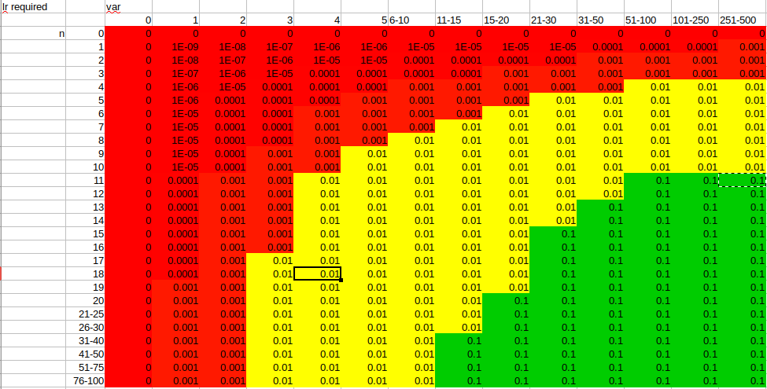

Bag Fraction, BF
Explain BF
0.5 to 1
Relationship with n
Hard limit in dismo gbm code, hence gbm.bfcheck
Plot: X = BF, Y = perf. Z = n.
See “K BF testing training” doc in this folder

Tree Complexity, TC
Explain TC
2:n(expvars)
Plot: X = TC, Y = perf. Z = n.

Speed
Algorithmic selection of the presumed-best variables will save time, increasingly so with larger datasets. While maximising model performance is clearly a main aim for users, increasingly precise performance scores are only so relevant. A model that takes a day to report a score of 0.987654321 likely confers few benefits compared to one that take two minutes to report a score of 0.99. If there are instances where significant speed improvements can be achieved with insignificant performance decreases, such a trade-off may be attractive to many. Certainly appraising users of this situation and allowing them to choose would be a boon.

How to do this? Do the speed testing code in the R book, keep these results.

Model Distribution
Bin gaus poisson others. Need data that are actually distributed that way.
How do these affect scores? Run everything above for each model distribution.
Delta/hurdle model: anything affected by this? Is presumably the product of two independent results described above and thus warrants a mention but little more?

Bringing It All Together
Need to see interim results to conceive compound solution.
Probably LR & BF relate to N; TC relates to N(expvars). Speed related to N * N(expvars)
Any impact of variability of data? Long-tailedness / shape in general?

Dream Solution
Gbm.optim analyses the data for zero inflatedness, predicts the distribution (for second part of a delta if ZI), then suggests hyperparameters values based on n, n(expvars), variance, shape.
Could build into gbm.auto: @param optim run automatic hyperparameter optimisation script, determining best lr bf & tc values, overriding user values if present?
@param optim balance passed to gbm.optim, sets the trade-off value between speed and performance, 0:1, default 0.5

How to actually do this in code
Loop through (foreach?), with pared-down gbm.auto (gbm.step no plots??, basic report output, including time elapsed & all params)
- Growing datasets: have a range of common sizes, 5, 10, 15, 20, 25, 30, 40, 50, 75, 100, 200, 400, 600, 1000, 1500, 2k, 4k, 8k, 20k, 50k, 100k, 500k, 1m, 5m
  - Different distributions: bin, gaus, pois, others, & delta bin+all others
    - TC 2 to N in integers
      - BF 0.5 to 0.95 in increments of 0.05
        - LR 0.5 to 0.000000001 in increments of 0.5, 0.1, 0.05, 0.01 etc.

Make plots of each relationship, 3D? Describe curves mathematically, derive equations, resulting in a formula for tc lr bf as solved for n, n(expvars), variability, shape.

